How To Install Eclipse IDE in Linux Mint

Eclipse is widely used IDE (Integrated Development Environment) for Java Applications. It can be used for developing applications using other programming languages like C++, PHP, R, Ruby and Scala.

Eclipse IDE is written in C and Java. It is released under public license. In this article, we shall see how to install Eclipse IDE Linux Mint.

Prerequisites:
1) User should have sudo privileges (i.e., user should have installation rights).

Note:
For pasting the copied content, ctrl+c(Copy shortcut) will not be useful in Terminal. You can go either with Edit -> Paste or by right click and select Paste in the popup.

Steps:
1. Open Terminal.
2. Type the below command first.
sudo apt update

It may ask for password, in case you set any password previously. Otherwise, Linux will be updated.
3. Install the curl package to download the Eclipse IDE from the internet using Terminal.
For this, type the below command.
sudo apt install -y curl

This will install the latest curl package in Linux mint.
4. Eclipse requires Java 8 or above in your machine. For installing OpenJDK, type the below command.
sudo apt install -y openjdk-11-jdk

This will install Java 11 from Open JDK in your machine.
5. Once Java installation is done, we can easily verify by giving the below command.
java -version
6. Now, we are in right step to install eclipse.
7. To install eclipse through Terminal, follow the below steps.
7.1. Go to this web page -http://ftp.jaist.ac.jp/pub/eclipse/technology/epp/downloads/release/
7.2. Check for the latest directory. Now it is 2020-03/. Click on that folder.
7.3. In that folder, search for folder named as ‘R’ (‘R’ stands for Release). If there is no such folder, please come out and check for previous directory (i.e., 2019-12/)
8. Now, click on ‘R/’ folder. Check the URL – It will be similar to http://ftp.jaist.ac.jp/pub/eclipse/technology/epp/downloads/release/2019-12/R/
9. Search for eclipse-jee-2019-12-R-linux-gtk-x86_64.tar.gz
10. This is the tar file (tar is similar to zip file), we need to download. For downloading through terminal, copy the same.
11. Give the below command in Terminal.
curl ftp.jaist.ac.jp/pub/eclipse/technology/epp/downloads/release/2019-12/R/eclipse-jee-2019-12-R-linux-gtk-x86_64.tar.gz -O
12. After downloading, extract Eclipse package to your desired directory (Ex. /usr/) as below.
sudo tar -zxvf eclipse-jee-2019-*-R-linux-gtk-x86_64.tar.gz -C /usr/

13. Now, create symbolic link. Give the below command.

sudo ln -s /usr/eclipse/eclipse /usr/bin/eclipse

14. If you want to have Eclipse Launcher icon, you can have through the below command.

sudo nano /usr/share/applications/eclipse.desktop

With this command, we can quickly start the application from the start menu of Linux Mint.
15. Remove the existing content (if any) and paste the below content there.

[Desktop Entry]
Encoding=UTF-8
Name=Eclipse IDE
Comment=Eclipse IDE
Exec=/usr/bin/eclipse
Icon=/usr/eclipse/icon.xpm
Terminal=false
Type=Application
Categories=Development;Programming
StartupNotify=false
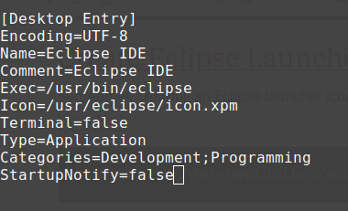

16. After adding, click ‘ctrl+x’. Click ‘y’ for yes, if it is asked.
17. Now, everything got over. Type eclipse in Terminal.

18. When eclipse IDE is launched, we could see the below popup.
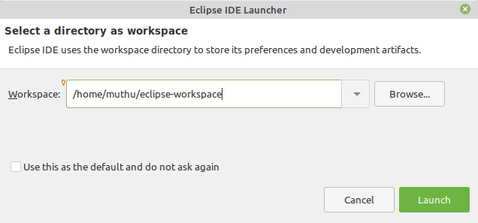
19. In the above popup, we can change the Workspace location, if needed – by clicking ‘Browse...’ button.
20. Now, click on ‘Launch’ button.
21. Below is the screenshot of Welcome page in Eclipse IDE.
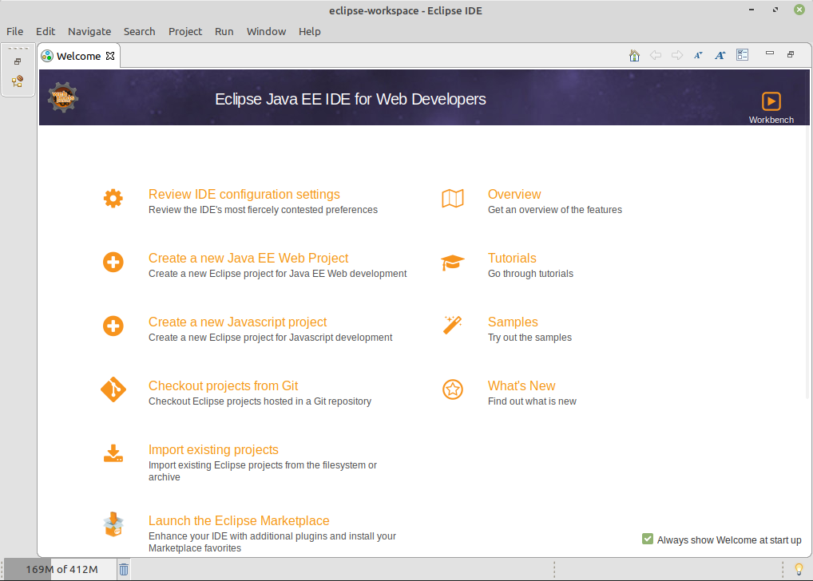
22. Close the Welcome screen by clicking on ‘x’ symbol nearby Welcome tab.
23. Now, we can see the below page.
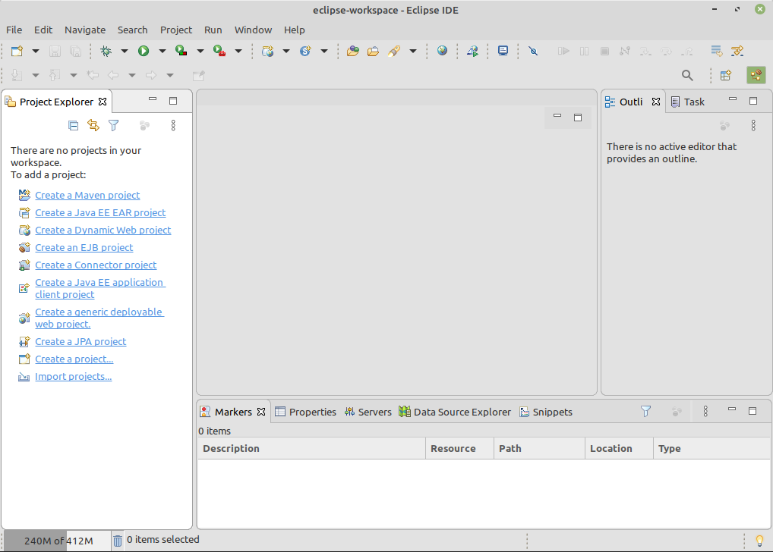
24. If you want to see the version details of Eclipse IDE, go to Help -> About Eclipse IDE. We can get the below popup with Eclipse IDE version details.

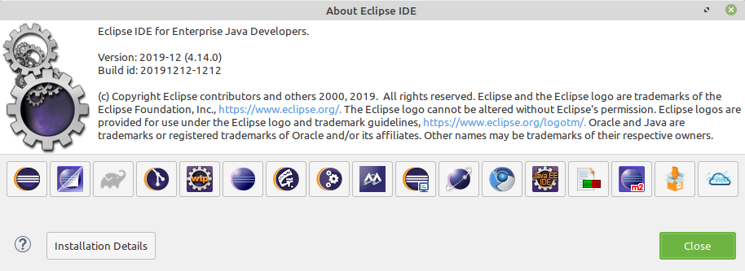

Conclusion:
Thats all! Successfully, we have completed installation of Eclipse IDE in Linux Mint.

